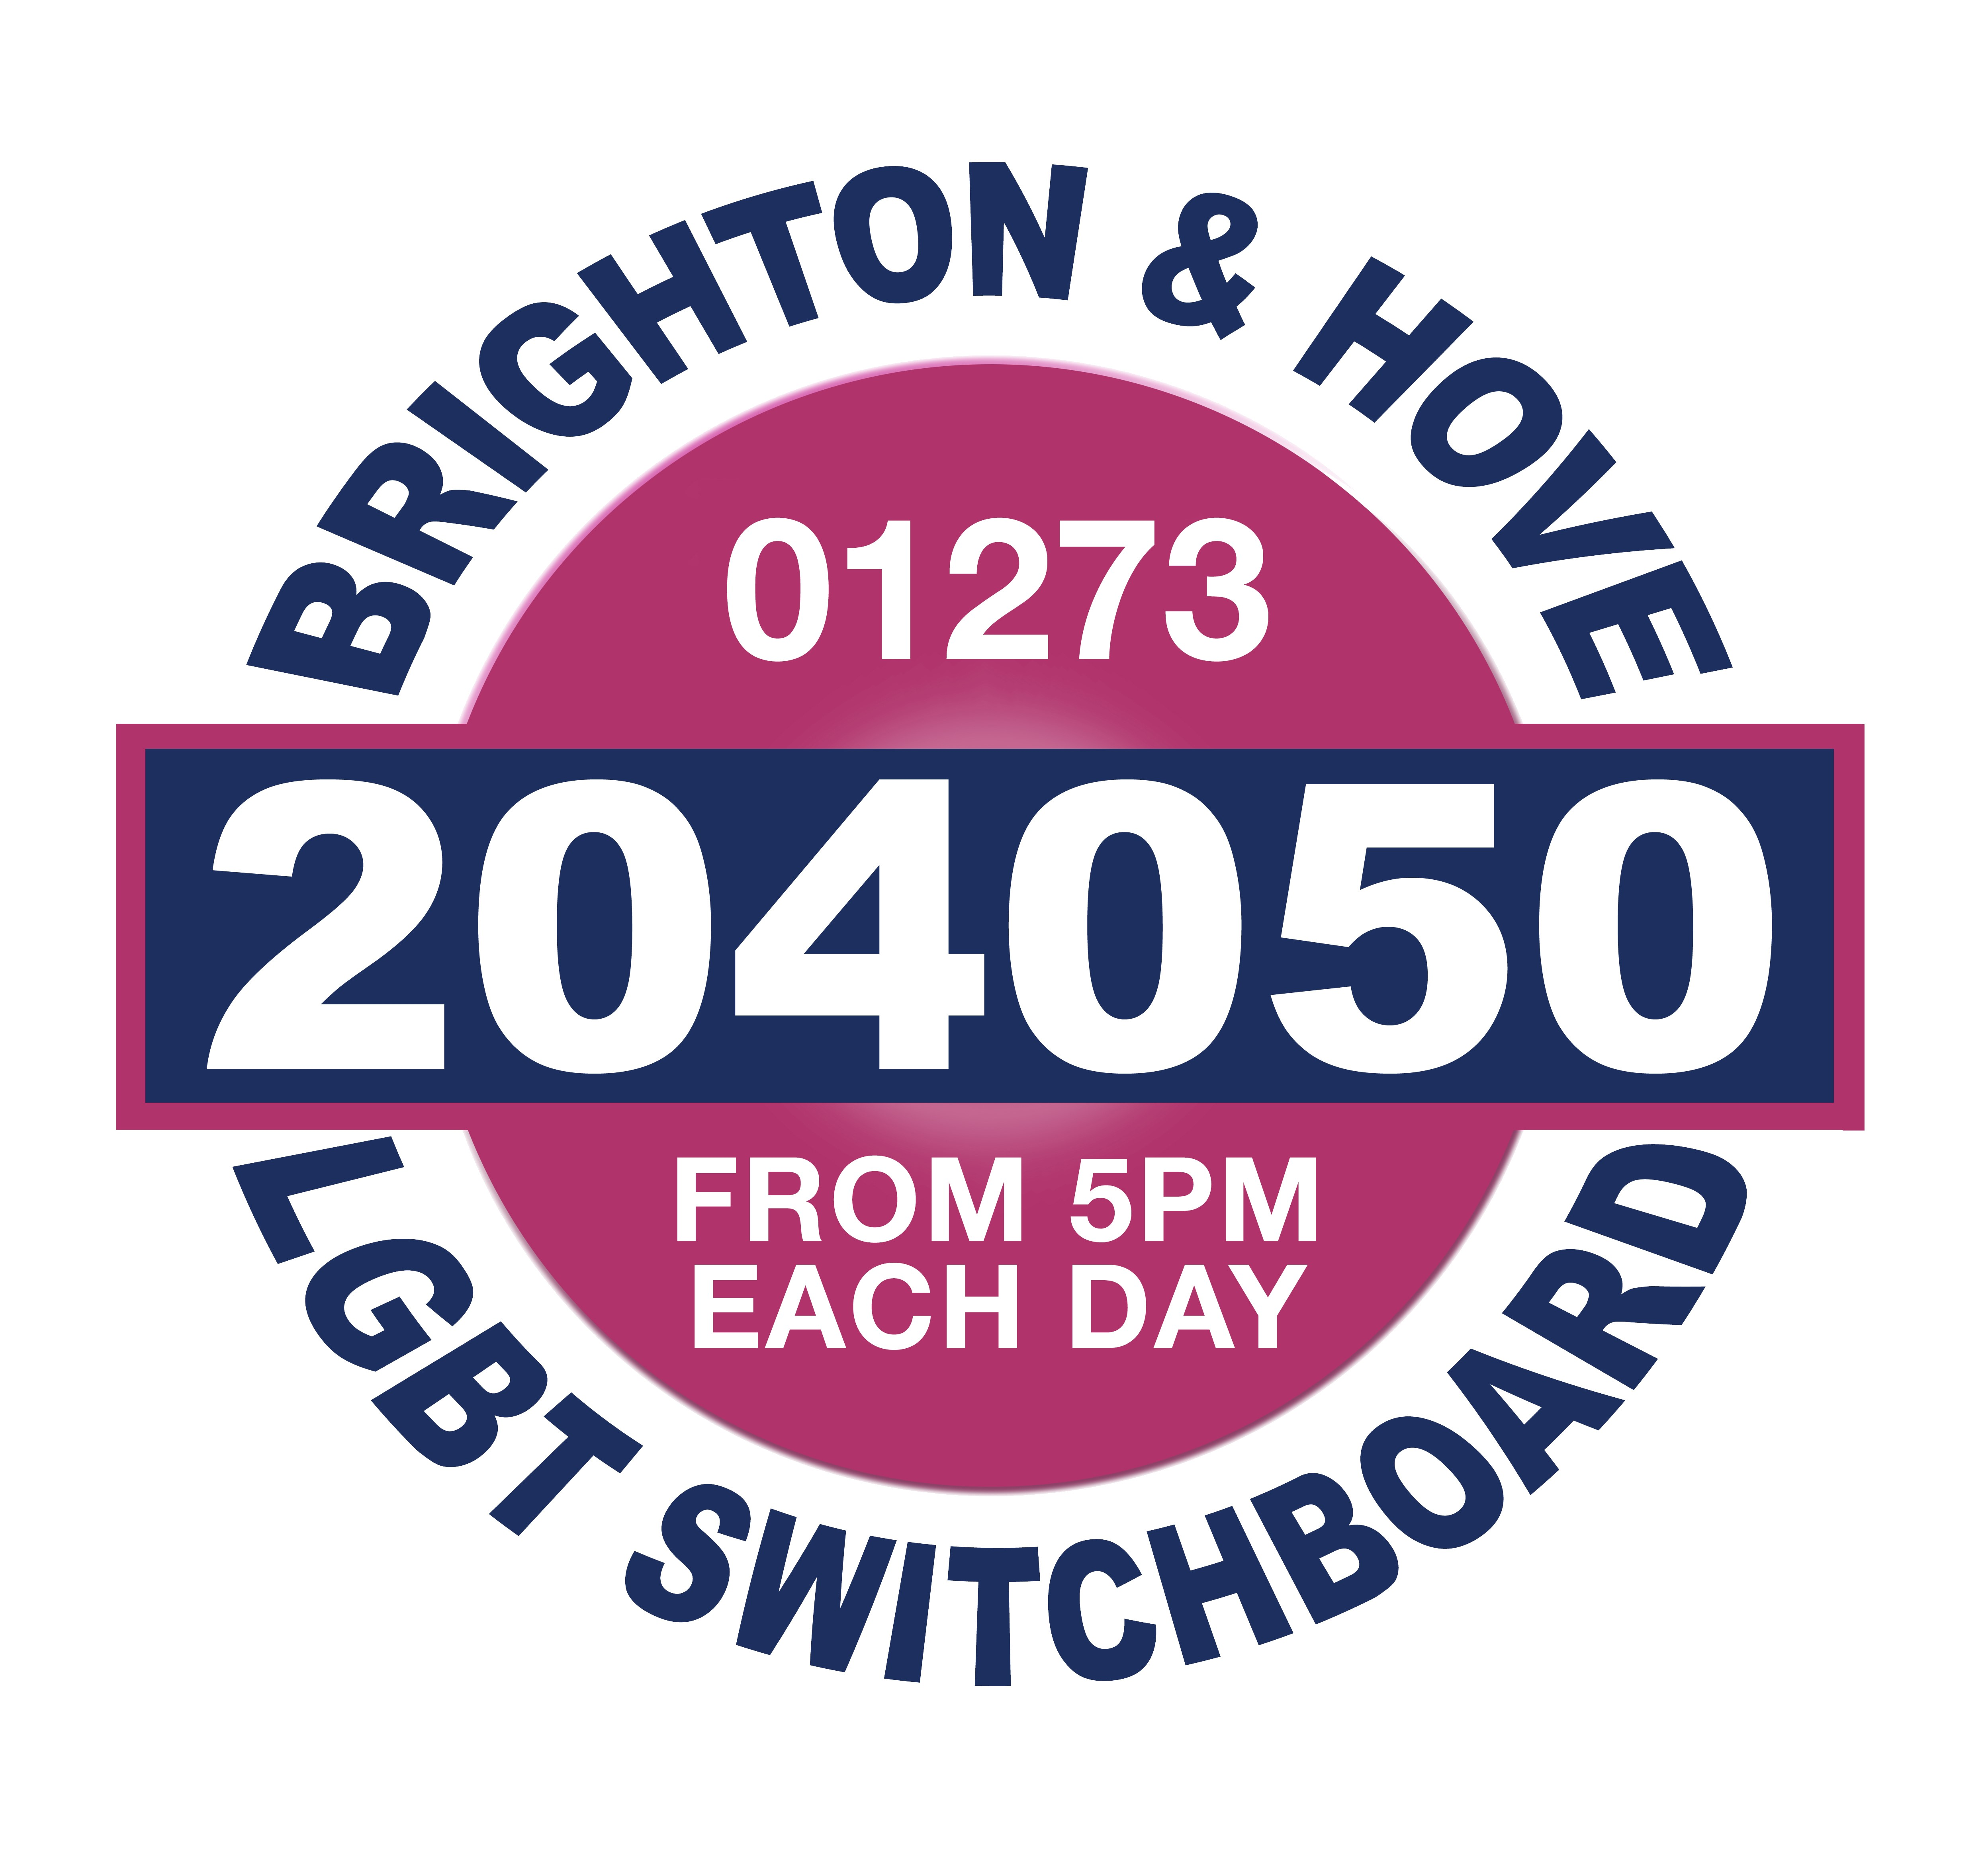

Please return this form to:
Switchboard’s Counselling Service
Community Base
113 Queens Road
Brighton
BN1 3XG
Or email it to: katie.dennis@switchboard.org.uk

Client code: ----/------ (for office use only)

Your Name: --------------------------------------------------

Your Address: --------------------------------------------------------------------------------------------

--------------------------------------------------------------------------------------------------------------

-------------------------------------------Postcode: ------------------------------Age: -------------------

Contact Numbers.

Daytime (Include STD code) -----------------------------------------------------

Please tell us if we need to be discrete, and if you would prefer us not to leave a message for you when calling you on this number.
----------------------------------------------------------------------------------------------------------------------------------------------------------------------------------------------------------------------------------------------------------------------------------

Evening (Include STD code) ----------------------------------------------------------------

Please tell us if we need to be discreet, and if you would prefer us not to leave a message for you when calling you on this number.
--------------------------------------------------------------------------------------------------------------------------------------------------------------------------------------------------------------------------------------------------------------------------------------------------------------

If it is difficult for a counsellor to contact you by telephone would you prefer correspondence by letter?

-----------------------------------------------------------------------------------------------------------------------------------------------------

If so, and if the address for correspondence is different from the one given above, please give the alternative address below.
----------------------------------------------------------------------------------------------------------------------------------------------------------------------------------------------------------------------------------------------------------------------------------

Client code: ----/------

We appreciate that this form may take some time to complete. However, considering and answering the following questions will help both you and your counsellor to start thinking about whether counselling with our organisation is the best option for you at this time.
The information you provide here will be held confidentially, and will be stored separately from any of the above information you have provided that identifies you. All applications that are e-mailed to the service will only be viewed by those people responsible for processing applications.
The next stage in your request for counselling is that you will be invited for an initial assessment session to explore further with a counsellor how counselling may be of help to you.

Why are you currently seeking counselling?
------------------------------------------------------------------------------------------------------------------------------------------------------------------------------------------------------------------------------------------------------------------------------------------------------------------------------------------------------------------------------------------------------------------------------------------------------------------------------------------------------------------------------------------------------------------------------------------------------------------------------------------------------------------------------------------------------------------------------------------------------
Why have you decided to access counselling now, as opposed to a few weeks/months/years ago? Has anything triggered this decision?
---------------------------------------------------------------------------------------------------------------------------------------------------------------------------------------------------------------------------------------------------------------------------------------------------------------------------------------------------------------------------

The counselling service offers a maximum of 12 counselling sessions. How do you think 6-12 counselling sessions will help? What do you hope to be different for you at the end of the 6-12 sessions?
-----------------------------------------------------------------------------------------------------------------------------------------------------------------------------------------------------------------------------------------------------------------------------------------------------------------------------------------------------------------------------------------------------------------------------------------------------------------------------------------------------------------------------------------------------------------------------------------------------------------------------

Do you currently receive any professional help/support from any other mental health professional, for example another counsellor/therapist, psychologist, psychiatrist, CPN, etc? Please give details.
----------------------------------------------------------------------------------------------------------------------------------------------------------------------------------------------------------------------------------------------------------------------------------------------------------------------------------------------------------------------------------------------------------------------------------------------------------------------------------------------------

Are you currently receiving any treatment or medication for any physical or mental health problem? Please give details.
----------------------------------------------------------------------------------------------------------------------------------------------------------------------------------------------------------------------------------------------------------------------------------------------------------------------------------------------------------------------------------------------------------------------------------------------------------------------------------------------------------------------------------------------------------------------------------------------------------------------------

G’P’s details:

Name: ----------------------------------------------------------------------------------------------------------------
Address: -------------------------------------------------------------------------------------------------------------------------------------------------------------------------------------------------------------------------------------------------------------------------------------------------
Telephone: -----------------------------------------------------------------------------------------------------------

Client code: ----/------

Have you ever had counselling before? (Please circle)
Yes No
If yes, how would you describe that experience?
-----------------------------------------------------------------------------------------------------------------------------------------------------------------------------------------------------------------------------------------------------------------------------------------------------------------------------------------------------------------------------------------------------------------------------------------------------------------------------------------------------------------------------------------------------------------------------------------------------------------------------
Who are the most significant/supportive people in your life?
-----------------------------------------------------------------------------------------------------------------------------------------------------------------------------------------------------------------------------------------------------------------------------------------------------------------------------------------------------------------------------------------------------------------------------------------------------------------------------------------------------------------------------------------------------------------------------------------------------------------------------

Counselling sessions are offered at a regular time and day once per week. Are you able to commit to this for a period of 6-12 weeks? (Please explain if this is difficult, for example if you work shifts.)
---------------------------------------------------------------------------------------------------------------------------------------------------------------------------------------------------------------------------------------------------------------------------------------------------------------------------------------------------------------------------

All of our counsellors are volunteers and most work at specific times. If your availability is restricted there may be a delay in allocating you a counsellor whose availability matches yours.

Please tell us the days and times that you are available to see a counsellor.

Weekdays Morning Afternoon Evening

Weekends Morning Afternoon Evening

Anytime

All of the counsellors who work for the service are qualified counsellors, or are working towards a recognised counselling qualification. All of the counsellors identify as lesbian, gay, bisexual and/or transgender. If you have any specific requirement that needs to be considered when allocating you a counsellor please write this below, otherwise leave this space blank.

--------------------------------------------------------------------------------------------------------------------------------------------------------------------------------------------------------------------------------------------------
-------------------------------------------------------------------------------------------------------------------------

Our counselling rooms are not wheelchair accessible so please tell us of any physical access limitations, to enable us to arrange an alternative venue for you.

------------------------------------------------------------------------------------------------------------------------------------------------------------------------------------------------------------------------------------------------

Client code: ----/------

We are a non-profit making organisation and rely on your payments to cover our costs. We use the following scale of charges. Please put a cross next to the level of payment you intend to make.

unwaged/receiving benefits: £5 per session

Earning below £10,000 per year: £7.50-£10 per session

Earning £10,000-£15,000 per year: £15 per session

Earning £15,000-£20,000 per year: £20 per session

Earning £20,000-£25,000 per year: £25 per session

Earning over £25,000 per year: £35 per session

Earning over £35,000 per year: £40 per session

We aim to provide an accessible service and we try to take account of individual financial restrictions where possible.

If you are concerned about your ability to pay prior to your application please contact the Support Services Manager on 01273 234009

To enable us to target our service effectively please tell us how you became aware of the Switchboard’s Counselling Service. (Please mark with a cross and give details where requested)

Switchboard help-line Switchboard website
Press (Please state which press)
Leaflet (Please state where leaflet was obtained)
Community Organisation (Please state which one)
G.P./Health Services (Please state which services)
Personal Recommendation Other (please specify

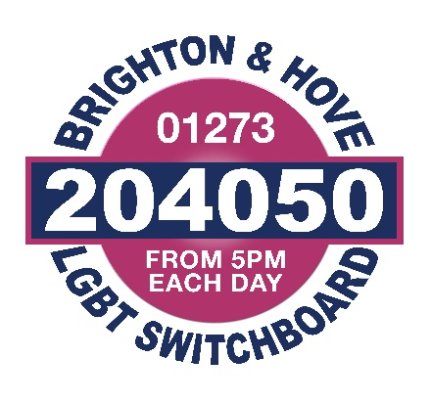

Equalities Monitoring Form

The reason why we ask you these questions is so we can:
- Treat everyone fairly and appropriately when they use our service.
- Meet the requirements of the funders.

The Equality Act 2010 makes these aims part of our legal duties. Your answers help us check that we have met the law and help improve our services.

Your answers are completely anonymous and confidential. We will only use them to make services better. Information from forms is combined so you cannot be identified.

What age are you? |  | ……… years  ◻ Prefer not to say
What gender are you? |  | ◻ Male ◻ Female  ◻ Other – please state … …………  ◻ Prefer not to say
Do you identify as the gender you were assigned at birth?  For people who are transgender, the gender they were assigned at birth is not the same as their own sense of their gender. |  | ◻ Yes ◻ No  ◻ Prefer not to say
How would you describe your ethnic origin?
White  ◻ English / Welsh / Scottish /  Northern Irish / British  ◻ Irish  - Gypsy or Irish Traveller  - Any other White back-ground (please give details)  ……………………………  Asian or Asian British  ◻ Bangladeshi  ◻ Indian  ◻ Pakistani  ◻ Chinese  ◻ Any other Asian background (please give details)  …………………………… | Black or Black British  ◻ African  ◻ Caribbean  ◻ Any other Black background (please give details)  ………………………………  Mixed  ◻ Asian & White  ◻ Black African & White  - Black Caribbean &White  ◻ Any other mixed  background (please give  details)  …………………………… |  | Other Ethnic Group  - Arab  ◻ Any other ethnic group (please give details)  ……………………………...  ◻ Prefer not to say

Which of the following best describes your sexual orientation?
◻ Heterosexual/ Straight
◻ Lesbian/ Gay woman
◻ Gay man
◻ Bisexual
- Other (please state) …………………………………………………………..
◻ Prefer not to say
What is your religion or belief?
◻ I have no particular religion  ◻ Buddhist  ◻ Christian  ◻ Hindu  ◻ Jain  ◻ Jewish  ◻ Muslim | ◻ Pagan  ◻ Sikh  ◻ Agnostic  ◻ Atheist  ◻ Other (please state)  ……………………………. |  |  | ◻ Other philosophical belief (please state)  ………………………..............  ◻ Prefer not to say
Are your day-to-day activities limited because of a health problem or disability which has lasted, or is expected to last,  at least 12 months? |  | ◻ Yes a little  ◻ Yes a lot  ◻ No (do not answer the next question)  ◻ Prefer not to say (do not answer the next question)
If you answered ‘yes’, please state the type of impairment. If you have more than one please tick all that apply. If none apply, please mark ‘other’ and write an answer in.
(Examples are given in the guidance)
◻ Physical Impairment ◻ Long-standing Illness
◻ Sensory Impairment ◻ Mental Health Condition ◻ Learning Disability/Difficulty ◻ Developmental Condition
◻ Other (please state) ………………………………………………………………………
Are you a carer?  A carer provides unpaid support to family or friends who are ill, frail, disabled or have mental health or substance misuse problems. |  |  | ◻ Yes  ◻ No  ◻ Prefer not to say
If yes, do you care for a…….? |  |  | ◻ Parent  ◻ Child with special needs  ◻ Other family member  ◻ Partner / spouse  ◻ Friend  ◻ Other (please give details) …………………………………………
Armed Forces Service:  - Are you currently serving in the UK Armed Forces (this includes reservists or part-time service, eg: Territorial Army)?  - Have you ever served in the UK Armed Forces?  - Are you a member of a current or former serviceman or woman’s immediate family/household? |  |  |  |  | ◻ Yes ◻ No  ◻ Yes ◻ No  ◻ Yes ◻ No

Thank you for completing this form.

