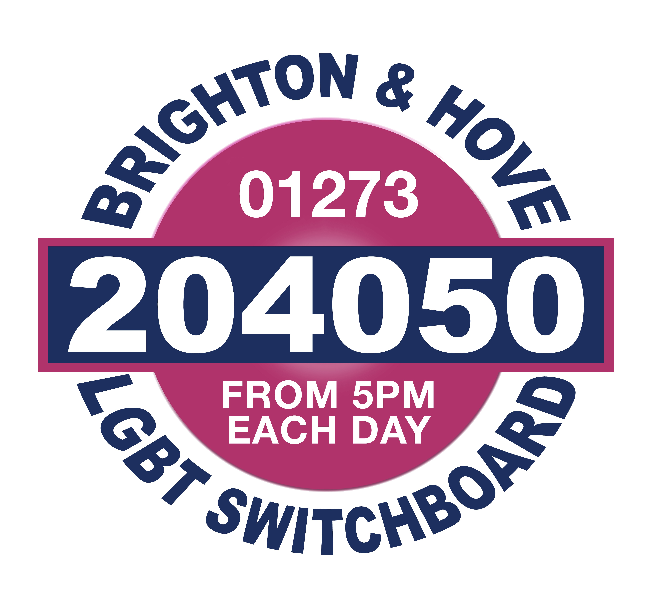

WHAT IS COUNSELLING?
Counselling occurs when a Counsellor meets with a
client in a private and confidential space to explore
with the client difficulties they may be having, distress they may be suffering, or a general dissatisfaction with life that they may be experiencing.
In the Counselling sessions the client is enabled by the Counsellor, who neither judges nor offers advice, to explore various aspects of their life and associated feelings by talking about them freely and openly in a way that is rarely possible with family and friends.
The relationship between the Counsellor and the client is an essential part of the process. As trust is developed the Counsellor will assist the client to look at aspects of themselves, their life and their relationships that the client may not have thought of, or felt able to face before.

HOW MIGHT COUNSELLING HELP?
Bottled up feelings such as anger, anxiety, grief and shame can become very intense. An opportunity to express and understand such feelings can help to reduce the pain that they can cause. The Counsellor will encourage such feelings without becoming burdened by them.
Talking with a Counsellor in this way can help you to discover more about yourself, for example your strengths, weaknesses, values and priorities. By talking with a Counsellor you will be encouraged and enabled to find your own understandings and solutions so that you can take some action for yourself.
Counselling can sometimes stir up difficult emotions as it may involve talking about painful things, so the counselling process is not always an easy one.

DO ALL COUNSELLORS WORK IN THE SAME WAY?
Counsellors vary in their approach depending on their theoretical beliefs and training. For example some may feel that exploration of earlier experiences and relationships are important in understanding the client’s current difficulties. Other Counsellors focus more on the here and now and don’t put so much emphasis on the past. Whatever approach Counsellors use it is for the client to make their own choices and decisions, and to put things into action for themselves.

WHAT IS A LESBIAN, GAY, BISEXUAL, AND TRANSGENDER AFFIRMATIVE COUNSELLOR/THERAPIST?

LGBT Affirmative Counselling is not a specific way of training and working for Counsellors. An LGBT Affirmative Counsellor can be simply described as having a range of beliefs, values, knowledge, experiences, and self awareness that enables them to accept and affirm their client’s gender and sexuality as being fine, normal, and equally valid, and to have an understanding of the issues that affect LGBT people. You can expect your LGBT Affirmative Counsellor to:

Respect various expressions of sexuality and gender and see them all as equally valid, whilst acknowledging the ways in which they are different.
- Have an understanding of the issues that are particular to the lives of LGBT people, for example: Homophobia and Transphobia, coming out issues/difficulties, lack of role models in family and society, same sex relationships, LGBT culture and services.

WHAT CAN I EXPECT ONCE I HAVE APPLIED FOR COUNSELLING WITH THE COUNSELLING PROJECT?

Once your application has been received by the Counselling Coordinator you will be contacted within ten days. This will either be to inform you approximately how long you will be waiting for an initial assessment session, or, if there is no waiting list, it will be to offer you an initial assessment session.

The initial assessment session is to give you and the Counsellor the opportunity to establish if Counselling with our organisation is the right thing for you. This session will be different from any future Counselling session that we may offer you; the Counsellor will be asking you questions and taking notes. It is also a time for you to ask questions and to make sure that you still want to go ahead with Counselling.

Please allow up to 50 minutes for this session. You will be charged for the initial assessment session at the rate that you have indicated you will pay for your counselling sessions on your application form. This fee is payable at the assessment session.

The Counsellor who meets you for this initial assessment session may not be the same Counsellor who is allocated to work with you if you take up an offer of Counselling. You will also be informed at this stage of some important issues, for example the length of sessions, confidentiality, what happens if sessions are missed and our complaints procedure.
Once the assessment session has been completed and a decision has been made by both parties to commence Counselling with our organisation, you will be contacted by your allocated Counsellor and sessions arranged. If following your assessment the Counsellor thinks that The Counselling Project is not the right service to best meet your needs they will contact you to inform you of this, and will do their best to assist you in finding an appropriate service.

If you have any questions about our service or your application between applying for Counselling and being allocated a Counsellor, you can contact Support Services Manager - Katie Dennis on 01273 234009.

