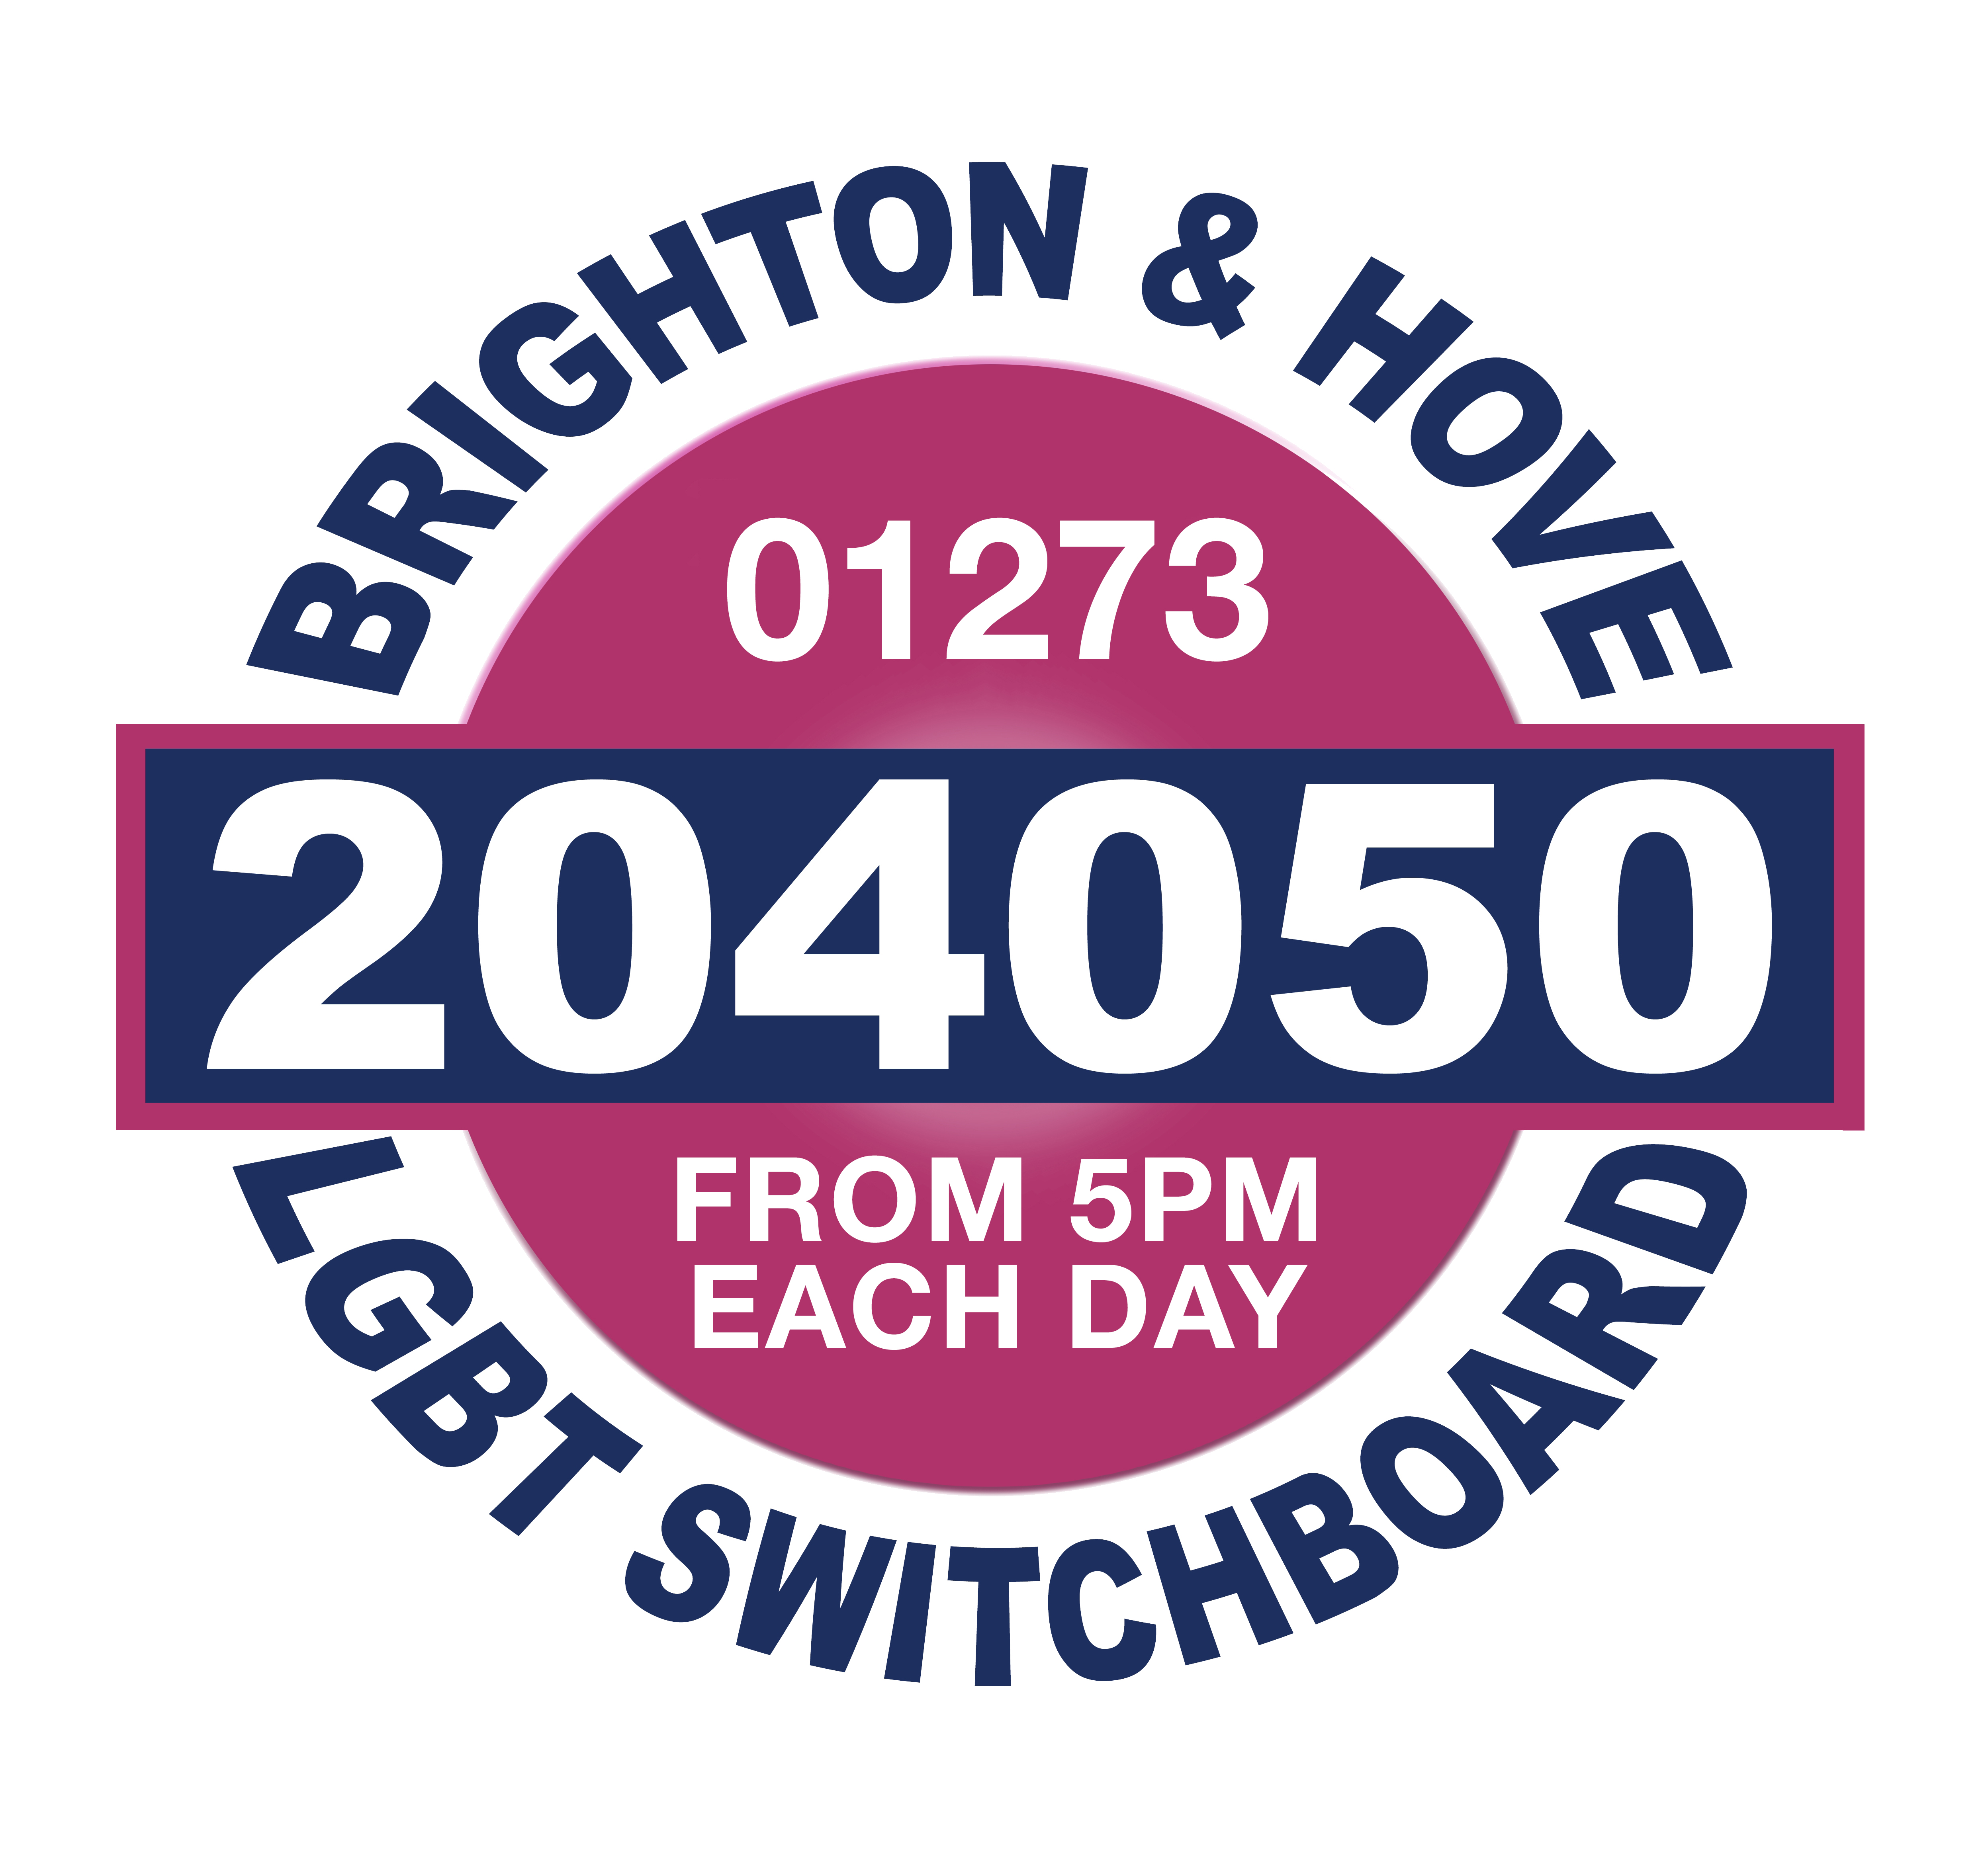

**March 2016**

Dear Applicant

Thank you for your interest in the position of Chief Executive Officer at LGBT Switchboard in Brighton and Hove.

After 15 years of successfully leading the organisation, our current Director is moving on to fresh challenges and we are looking for a new Chief Executive Officer to move the organisation into its next phase of development. This is an important and exciting time to join Switchboard – we have a dedicated and well-performing staff team, a range of projects and services, an effective governing body and a vision for the future.

At 40 years of age, Switchboard is the longest-running LGBT organisation in Brighton and Hove. As well as our volunteer-run helpline, we have added a highly valued counselling service, a well-used and loved older people’s project and a successful and effective Health Inclusion Project.

However, we are also in challenging times – demands for services are increasing, public sector funds are being cut and there is a need to diversify income. There are greater pressures for organisations to evidence impact and value for money. Our new Chief Executive Officer will embrace these challenges and use their senior leadership skills and strategic vision to lead the organisation over the next few years.

For a relatively small organisation like Switchboard, we are looking for a strong all-rounder who has a broad skill base and is able to manage both strategically and operationally. Key will be fundraising and income generation skills and track record – we have some tough income generation targets to achieve and we need a confident leader to help achieve them. You will work with trustees, staff and volunteers to build a resilient and sustainable organisation that is responsive to the needs of our service users and the local LGBT community.

The successful applicant will have a unique and exciting opportunity to help create a lasting legacy for the LGBT communities in Brighton and Hove and to make a real difference to people’s lives. If this appeals to you we would love to hear from you.

If you would like to speak to someone about this role, please contact either Kelly Rust or Anne-Marie Donnelly on the email addresses below.

If you are interested in applying, please send a CV with a covering letter (no more than 3 sides of A4) to [Kelly.rust@switchboard.org.uk](mailto:Kelly.rust@switchboard.org.uk) by Friday 22 April at 10am. Please also completer and return the equalities monitoring form. Interviews will be held on Friday 6 May.

With best wishes

Kelly Rust and Anne-Marie Donnelly (Trustees)

Kelly.rust@switchboard.org.uk

Anne-Marie.donnelly@switchboard.org.uk

**Who we are**

Brighton & Hove LGBT Switchboard is a community organisation supporting local LGBT people to improve their health and wellbeing. We offer a telephone help-line, a face to face LGBT specialist counselling service, an LGBT Older People’s project and an engagement project giving local LGBT people a voice and supporting the development of LGBT communities.

Volunteering is a key part of our work and we have approximately 30 fantastic volunteers delivering our help-line and counselling services. We currently have 6 staff.

We work in partnership with over 25 local community and voluntary sector organisations, we have good relationships with the city council and health authority and we are proud to have reached our 40th birthday last year.

**Chief Executive Officer **

**Recruitment Pack**

**Job Title:** Chief Executive Officer

**Reports to:** Chair of Trustees

**Salary:** £35-40k (negotiable)

**Hours of work:** 37.5 hours per week. The post holder will be required to work flexibly within an agreed number of hours to maintain the most appropriate level of service provision. This will include some evening and weekend work

**Terms:** Permanent position to be confirmed following six month probationary period

**Job Purpose**

The CEO is responsible for providing strategic and operational leadership to the LGBT Switchboard and will play a key role in income generation and delivering on the vision, mission, values and strategic plan.

**Planning and development**

• In conjunction with the Board of Trustees, develop, implement and monitor the strategic and operational plans.

•Translate organisational objectives into team and individual work plans with clear and realistic targets.

•Maintain an awareness of the operating environment such as those legislative developments, social trends and local needs likely to affect demand for service users and opportunities for service development.

•Develop IT and other resource needs and strategies.

•Manage the development of the organisation to ensure that the strategic development of Switchboard, its management and its services reflect and support the strategy and most effectively serve the needs of the LGBT community we serve.

**Fundraising**

•Develop the organisation's funding base by identifying potential funding opportunities consistent with the aims of the organisation and the operating environment, and apply for funding in accordance with a fundraising strategy as agreed by the Board of Trustees

•Negotiate and review all grants and service agreements in consultation with the Board of Trustees, ensuring that existing services are adequately funded and appropriate grant applications are made

•Maintain appropriate relations with funders, fulfilling all reporting requirements and ensuring compliance with contracts

**Supporting the governing body**

•Arrange and attend meetings of the Board of Trustees, including the annual general meeting and any special general meetings.

•Advise and support the wider Board of Trustees on financial, staffing and service delivery issues and all other relevant legislation, e.g. company and charity law, health and safety, employment etc, in consultation with key lead Trustees.

•Report to the Board of Trustees on progress against the business plan and agreed objectives.

•Prepare and draft the organisation's annual report

**Service delivery**

•Develop the provision of high quality services to members of the LGBT community that are responsive and built around meeting the needs of service users.

•Maintain an awareness of organisational and technological developments and ensure that the service operates in ways which make best possible use of the resources available

•Encourage the use of innovative technologies in the delivery of our services to ensure they remain relevant to service users.

•Ensure, delegating as appropriate, that each project is adequately managed, staffed and resourced

•Develop and maintain common practices to ensure that standards of service delivery are met and appropriate systems are in place for staff supervision, case recording, statistics, follow-up work and quality control

**Financial management**

•Maintain day-to-day financial control of the service within budget heads agreed by the Board of Trustees

•Ensure that all finances are properly administered and monitored and that appropriate financial regulations and controls are in place and in use at all times

•Advise on the proper allocation of resources

• In conjunction with the Treasurer, prepare and review detailed budgets for approval by the Board of Trustees, liaising with the Finance sub-committee as necessary

• In conjunction with the Treasurer, make regular reports to the Board of Trustees on income, expenditure and any variations from budgets

•Oversee the correct preparation of accounts and financial statements in conjunction with the Treasurer and Finance sub-committee

•Ensure that all financial reporting obligations are met in relation to submissions for funding, grant aid, contracts and any other initiatives

•Act as cheque signatory and authorise expenditure up to limits as agreed by the Board of Trustees

**Staff management**

•Create a positive working environment in which equality and diversity are respected, dignity at work is upheld and staff are motivated to challenge themselves and reach their full potential.

•Ensure the effective performance management and development of all staff, through regular supervision sessions and the appraisal process

•Regularly evaluate staff learning and development needs and ensure that learning and development needs are identified and met.

•Convene and chair regular meetings of the team

•Establish and implement a recruitment, induction and staff development policy in conjunction with the appropriate sub-committee

• Implement and monitor employment policies and procedures

**Public relations and research and campaigns**

•Promote and protect the aims, principles, policies, interests and reputation of the LGBT Switchboard and ensure that the organisation has a high profile at all times

•Ensure the development of research and campaigns and instigate systems and procedures in line with the research and campaigns requirements

•Develop and oversee appropriate publicity through effective relations with the media and other community organisations, and through public speaking

•Develop effective relations with appropriate authorities, agencies, organisations and individuals at local and national levels, including councillors, MPs, MEPs and local and national statutory and non-statutory organisations

**Administration**

•Ensure there are effective administrative systems and complaints procedures in place

•Ensure that the service is adequately accommodated and equipped in consideration of the needs of clients and staff and the effective operation of the service

•Act as health and safety officer to ensure that health and safety policies and procedures for staff, premises and equipment are agreed and maintained and comply with statutory requirements

•Use ICT as required for the role

•Undertake such other duties as may lie within the scope of this post to ensure the effective delivery and development of the service

**Person specification**

*It is a genuine occupational requirement for this post that the person identifies as LGBT*

|  |  |  |
| --- | --- | --- |
|  | Essential (E)/ Desirable (D) | Application form (A)/ Interview (I) / Test (T) |
| Experience of working at a senior management, Director or CEO level | E | A, I |
| Understanding of the voluntary sector and, in particular, knowledge of the environment in which the Switchboard operates | E | A, I |
| Strong leadership experience, including developing people and organisations | E | A, I |
| Strong financial management skills and experience | E | A, T |
| Proven ability to devise and implement strategic development and operational plans | E | A, I |
| Track record of successful income generation, through fundraising, commissioning and marketing activities | E | A, I |
| Proven ability to communicate effectively in person and in writing with individuals and with a wide variety of organisations, and to research and interpret complex information and produce clear verbal and written reports | E | A, I, T |
| Capability to influence external change and the ability to earn and maintain the trust of those people with whom the Switchboard deals, especially funding bodies, donors and other key stakeholders in the LGBT community | E | A, I |
| The ability to commit to and work within the aims, values, principles and policies of the Switchboard | E | A, I |
| Ability to create a positive working environment in which equality and diversity are respected, dignity at work is upheld and staff are empowered and motivated to do their best | E | I |
| A good up to date understanding of equality and diversity and its application to service delivery, business development and the recruitment and management of staff and volunteers | E | A, I |
| Understanding of the issues faced by members of the LGBT community | E | A, I |
| Track record in project management | D | A |
| Proven ability and experience in managing change | D | A |
| Commitment to continuous professional development | D | A |
| Understanding of managing ICT and office systems | E | A |

Please ensure you address all the elements of the person specification that have an ‘A’ by them in your cover letter as these will form the basis of the shortlisting.